1. In addition to the directory we found above, there is another directory that can be found. What is it?

Ta quét tìm các thư mục ẩn của url :http://94.237.63.132:38808/

```bash

ffuf -w /root/SecLists/Discovery/Web-Content/directory-list-2.3-small.txt -u <http://94.237.63.132:38808/FUZZ>

```

Kết quả thu được

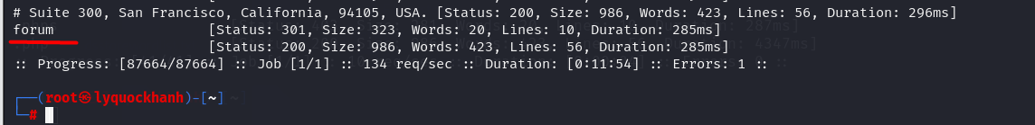

P/s : forum